**Meteorite Landing Patterns**

Exploring Meteorite Landing Patterns Through Clustering Analysis: A Data-Driven Approach

**Ujjwal Sharad Patil**

B.Tech Student ,Department of Information Technology, Shri Guru Gobind Singhji Institute of Engineering and Technology (SGGSIET), Nanded

*ujjwalpatil63@gmail.com*

**Dr. Ankush Sawarkar**

Professor,Department of Information Technology, Shri Guru Gobind Singhji Institute of Engineering and Technology (SGGSIET), Nanded

*adsawarkar@sggs.ac.in*

**Abstract :** Meteorite landings provide humanity with invaluable insights into celestial events by providing a deep window into the dynamic interaction of cosmic forces that shape our planet and the larger universe. Here, we employ state-of-the-art clustering techniques to examine a large dataset of meteorite landings that includes important attributes including name, ID, mass, fall categorization, year, geographic coordinates (latitude and longitude), and GeoLocation information. Through our work, we hope to reveal hidden patterns, time trends, and spatial distributions in the dataset that will help to clarify the complex dynamics of meteorite strikes on Earth's surface. We identify discrete clusters within the meteorite dataset and determine their temporal and spatial properties by carefully combining preprocessing procedures, clustering approaches, and exploratory data analysis. Remarkably, our research yields a commendable silhouette score of 0.565, indicating that KMeans is the best clustering approach for this dataset. By skillfully dividing the meteorite data into coherent clusters, this method makes it easier to find significant patterns and connections within the data. The drawn clusters depict a variety of spatial distributions, displaying landing concentrations in particular areas together with time variations in landing frequency. These results broaden our understanding of the dynamics of meteorite impacts and have significant ramifications for astrobiology, geology, and planetary science. Our research makes a substantial contribution to the field by clarifying the temporal and spatial complexities of meteorite landing patterns, highlighting the value of interdisciplinary approaches in planetary exploration. Furthermore, our results highlight how important meteorite impacts are in forming planetary surfaces and may have an impact on the origin and development of life. By means of such multidisciplinary pursuits, mankind persists in deciphering the enigmas of the cosmos, exploring the genesis of life within the universe and augmenting our comprehension of planetary mechanisms.

**Keyword :** Meteorite landings, Clustering analysis, Spatial distribution, Temporal trends, Exploratory data analysis

**Introduction :**

The physical remains of celestial events, meteorites are evocative reminders of the turbulent and dynamic processes that have molded our solar system over time. Meteorites have always been fascinating objects of wonder and fascination, from prehistoric societies who believed that falling stones had heavenly meaning to contemporary scientific investigations that painstakingly examine their composition. Centuries of painstaking documentation of meteorite landings have produced an enormous amount of data, including basic characteristics like mass and name, as well as more complex information like composition and trajectory. (IM Atiles Gil de Lamadrid - Revista Politechne,2022)[1].

There are many opportunities to explore this extensive collection of meteorite data in the modern era of sophisticated data analysis techniques. The prospect of revealing hidden patterns and structures within meteorite datasets lies in the application of cluster analysis, a powerful tool in the data scientist's toolbox. Through the classification of meteorite landings according to common characteristics like mass, location, and impact time, scientists can identify both temporal and spatial patterns that could provide important understandings of the mechanisms underlying meteorite impacts. (MA Vesconi, SP Wright, M Spagnuolo,2011)[2]

Our goal is to use state-of-the-art clustering techniques to precisely examine meteorite landing patterns. Our goals are to improve our knowledge of planetary dynamics and shed light on the physics of meteorite falls. We hope to detect patterns of regional clustering, detect changes in landing frequency over time, and find possible relationships between impact locations and meteorite attributes by methodically analyzing meteorite data. Primarily, we want to interpret the complex interactions between variables affecting meteorite landing distribution by combining advanced clustering methods with localized data from planetary and geological sciences.

Our research was conducted with a rigorous approach, which is reflected in the format of our work. We first give a summary of the methods used, the steps in the data processing process, the clustering algorithms that were used, and the metrics that were used to evaluate the quality of the clusters. The results of our clustering analysis are then presented, emphasizing the most important deductions and insights made from the information. We discuss the ramifications of our results for comprehending meteorite impacts and more general planetary dynamics, delving into the significance of our discoveries for planetary research.( DR Chapman , 1971)[3]

Our study highlights the non-uniform distribution of meteorite landings worldwide by revealing a mosaic of regional clustering patterns. We note localized factors impacting the occurrence of meteorite impacts in some places where we detect concentrations of impacts. Furthermore, our temporal trend analysis reveals variations in landing frequency among epochs, suggesting dynamic processes operating across geological periods. Crucially, we find relationships between impact locations and meteorite characteristics that provide insight into the varied origins and trajectories of meteoritic materials. We are able to obtain a better understanding of the mechanisms controlling meteorite impacts, from atmospheric entry to the ultimate crash with the Earth's surface, by combining knowledge from geology and planetary science.

Essentially, our research serves as evidence of the effectiveness of data-driven investigation in expanding our knowledge of astronomical events. By means of meticulous examination and interdisciplinary cooperation, we are getting closer to solving the mystery surrounding meteorite strikes, so expanding our understanding of planetary functions and the vast cosmic fabric of which we are but a little part.

**Literature Review**

For millennia, meteorite impacts have caught the attention of scientists and citizens both. These cosmic affects have had an important effect on Earth's history and have influenced our view of the world, from stories from history to modern scientific research. Alvarez et al.'s revolutionary study from 1980, which claimed that a meteorite impact was the reason for the extinction of the dinosaurs, rekindled interest in affect crater research. Since then, collaborative efforts and innovations in technology have empowered researchers to look more thoroughly into the makeup, distribution, and impacts of meteorite impacts.( Alvarez et al.'s,)[4]

Research on the composition of meteorites and its implications for solar system development has been conducted using databases such as the Meteoritical Bulletin, as demonstrated by the works of Rubin and Bottke (2009) [5] and Gattacceca et al. (2011) [6]. Through the examination of isotopic ratios, mineralogy, and chemical signatures, scientists have interpreted hints on the formation and motion of meteorites, providing insight into the mechanisms governing the formation and development of planets.

As shown by Jenniskens et al. (2009)[7] and Sears et al. (2016)[8], clustering analysis has proven useful in locating compositional and geographical patterns in meteorite datasets. Scientists have gained insights into the dynamics of solar system bodies and the genesis of meteorites by classifying meteorites according to their mineralogical and geochemical similarities. The distribution of resources in space and the possible risks that near-Earth objects pose to Earth are both affected by these result

It is still difficult to fully understand the effects of meteorite strikes, despite tremendous advances. Multidisciplinary studies, such the ones investigating the origins of life and the habitability of planetary surfaces (Cockell et al., 2016), shed light on the larger consequences of these cosmic occurrences. Through the investigation of extremeophiles found in impact craters and the examination of the geochemical indicators present at impact locations, researchers are gaining insights into the possibility of extraterrestrial life and the prerequisites for its existence.

Numerous disciplines and research methodologies are involved in the study of meteorite strikes, all of which advance our knowledge of planetary science and related topics. By combining a variety of approaches and using technology advancements, scientists are uncovering new insights into the fascinating field of meteorite strikes. We learn more about the dynamic processes forming the cosmos and the history of our own planet as we continue to solve the riddles surrounding these cosmic encounters.

**Methodology :**

**Data Preprocessing:**

Analyzing meteorite landing patterns is like starting a painstaking archaeological investigation into our planet's cosmic past. The starting point is the procurement of an extensive dataset from the Meteoritical Society, which includes 45,716 records covering 10 essential factors. To maintain its integrity, this raw dataset is refined through a complex procedure, similar to that of an uncut gemstone. Missing values are painstakingly filled in and duplicate entries are carefully found and eliminated so that the final dataset, like a polished jewel, has 10 columns and 38,115 immaculate rows that are ready to reveal their secrets.

The next step of the process, choosing the best clustering approaches, is calling now that the dataset is polished and shining like a well-prepared painting. It's like knowing just how to paint a picture with the correct brushstrokes. This choice has enormous implications since it creates the framework for analyzing the complex spatial and compositional fabric that makes up the meteorite data landscape. Every clustering method, like every creative method, has the potential to provide new information and insights that lead us farther into the mysterious world of meteorite impacts.

**Selection of clustering algorithm ;**

For this study, three clustering techniques are selected:

1. Agglomerative Clustering : Agglomerative clustering is a hierarchical clustering technique that starts with individual data points and combines them until a single cluster is established. It generates clusters by gradually merging smaller clusters based on their similarity.( Tan, P.-N., Steinbach, M., & Kumar, V., 2005) [9]
2. DBSCAN : Based on a predetermined distance and minimum number of points, the clustering method DBSCAN (Density-Based Spatial Clustering of Applications with Noise) clusters points that are densely packed together and identifies points in low-density regions as outliers.[9]
3. KMeans : By minimizing the sum of squared distances between data points and the centroid of each cluster they are assigned, the K-Means clustering method divides data into a predetermined number of clusters (k).[9]

Three different clustering approaches are important in the effort to untangle the complex web of meteorite data. The process is started by the very effective KMeans, which divides the dataset into three centroids-based clusters, essentially identifying the gravitational centers of meteorite concentrations. In the meantime, DBSCAN takes a more sophisticated technique, using an epsilon value of 0.5 and a minimum samples parameter of 5. It carefully scans the data landscape, spotting clusters in areas with high population density while tactfully classifying outliers as noise, giving rise to a thorough comprehension of meteorite distribution. Finally, a hierarchical technique is used in agglomerative clustering, which is similar to sculpting from clay. Clusters are merged recursively according to distance measurements, progressively exposing the underlying structure in the data until three coherent clusters form. From the centroid-based partitioning of KMeans to the density-focused exploration of DBSCAN and the hierarchical amalgamation of agglomerative clustering, each methodology provides a distinct set of insights that enhance our understanding of meteorite impacts and spatial patterns in the dataset.

**Clustering Analysis :**

After selecting an algorithm, each of the selected algorithms is applied to the dataset to do a clustering analysis. Until convergence is reached, KMeans iteratively allocates data points to the closest centroid and updates centroids. Agglomerative Clustering merges clusters hierarchically based on distance metrics, whereas DBSCAN locates core points within dense zones and expands clusters depending on predetermined parameters.

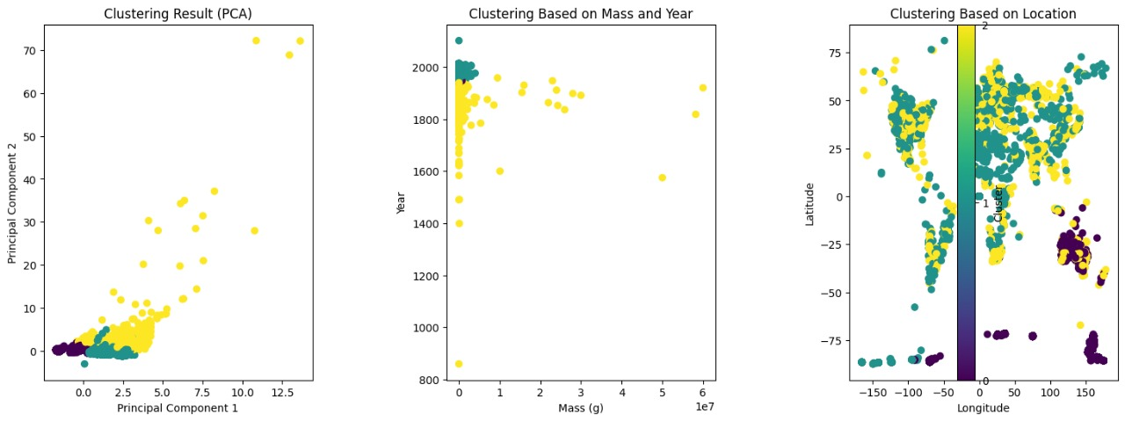

**Evaluation Matrics:**

Two evaluation criteria are used to assess the quality of the clustering results: the Davies-Bouldin index and the silhouette score. Higher silhouette scores indicate better-defined clusters. The silhouette score gauges the cohesiveness and separation of clusters. Lower values of the Davies-Bouldin index indicate higher clustering quality. The index evaluates the compactness and separation of clusters.

DB-Index :

***DBI = $\frac{\sum_{i=1}^{i=k}{\max{(j!=i)}(\frac{a+b}{c})}}{k}$***

Here

The number of clusters is k.

The centroid of cluster i is located at a, and the distance between each point in cluster i and its centroid is denoted by c.

Silhouette score :

**s(i) = $\frac{b\left(i\right)-a(i)}{max⁡[b\left(i\right), a(i)]}$**

here,

a(i) represents the average distance between i and all other data points belonging to same cluster (intra-cluster distance).

b(i) is the average distance between i and each and every data point in the closest nearby cluster (inter-cluster distance).

The best performance among the three clustering algorithms was indicated by **KMeans**, which produced the maximum **silhouette score** of 0.565133828523432, after evaluation metrics were computed for each clustering approach. As a result, the best clustering technique for dividing the dataset into coherent clusters was found to be KMeans. Ultimately, the KMeans-generated clusters are shown using suitable methods, like heatmaps or scatter plots, to learn more about the temporal and spatial trends of meteorite landings. These revelations advance our knowledge of the mechanics of meteorite impacts and its significance for geology and planetary science.

**Experimental Setup :**

We leverage the processing power of a laptop with a **Ryzen 5** processor and **16GB RAM** for our clustering research. This system setup offers a strong basis for carrying out data-intensive operations, such cluster analysis, without experiencing noticeable performance snags. We make use of the robust machine learning ecosystem that **Python** offers, which includes **scikit-learn**, **pandas**, and **numpy**. These packages provide strong tools for preparing data, putting clustering techniques into practice, and assessing model performance. Furthermore, Python is a great option for developing models and performing exploratory data analysis due to its comprehensive documentation and ease of use.

The Meteoritical Society provided the meteorite landing data that make up the dataset being analyzed. Name, id, nametype, recclass, mass (g), fall, year, reclat, reclong, and GeoLocation are among the attributes included in this collection. We carry out extensive data preprocessing to address missing values, duplicates, and any discrepancies in the data before moving on to clustering analysis. This establishes the foundation for trustworthy clustering findings by guaranteeing the dataset's quality and integrity.

Three primary algorithms—**KMeans, DBSCAN, and Agglomerative Clustering**—are the subject of our clustering investigation. Every approach has unique benefits and can be used for various kinds of data and clustering assignments.

**Hyperparameter Tuning :**

A critical step in enhancing the KMeans algorithm's performance is hyperparameter adjustment. We use a methodical technique to investigate a variety of options for the number of clusters (k), such as grid search or random search. Through the application of measures such as Davies-Bouldin index and silhouette score, we assess each configuration in order to determine which number of clusters best depicts the underlying structure of the data.

We use k-fold cross-validation to evaluate our clustering models' generalization performance and guarantee the accuracy of the findings. By using this method, the dataset is divided into k subsets, which makes it possible to train and test the models repeatedly on various subsets. We get accurate estimations of the clustering by averaging the performance throughout all iterations.

To make the most use of our computer resources, we placed efficiency and optimization first throughout the experimental setup. We take advantage of the **Ryzen 5 p**rocessor's multi-core capabilities by using parallel computing techniques, which expedites computations and shortens processing times overall. Furthermore, we optimize memory utilization during clustering tasks by minimizing needless data copying and utilizing memory-efficient programming techniques. All things considered, our experimental setup makes good use of the laptop's CPU power by utilizing powerful algorithms and optimization approaches to carry out thorough clustering analysis and extract valuable information from the meteorite landing dataset.

**Result :**

The results of the clustering analysis applied to the meteorite landing dataset provide valuable information about the temporal and spatial distribution of meteorite impacts. Based on the evaluation of clustering algorithms, KMeans is the most efficient approach with a silhouette score of 0.565133828523432. This statistic shows that the KMeans-generated clusters are highly cohesive and separated, and they are also well-defined. To further confirm the quality of the clustering results, the **Davies-Bouldin Index** for **KMeans** with **9 clusters** is computed to be 0.3410874713598496.

Formulas to calculate Evaluation matrix :

***DBI = $\frac{\sum_{i=1}^{i=k}{\max{(j!=i)}(\frac{a+b}{c})}}{k}$***

***s(i) = $\frac{b\left(i\right)-a(i)}{max⁡[b\left(i\right), a(i)]}$***

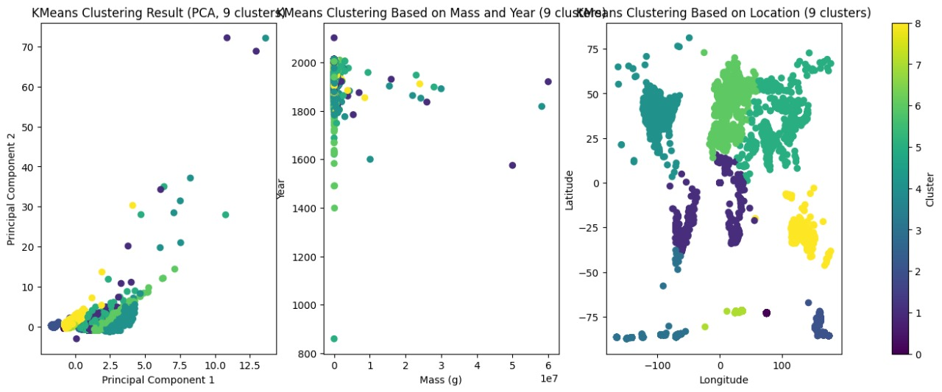

**Discussion :**

The spatial and temporal patterns that the clustering analysis revealed are displayed in the results presentation. An extensive picture of the distribution of meteorite landings can be obtained by visualizing the clustering results, especially with scatter plots of mass vs year and latitude versus longitude. The clusters that KMeans found indicate areas of frequent meteorite strikes and times of increased activity by revealing different spatial concentrations and temporal trends. These results offer important new information for further study and analysis as well as a greater knowledge of meteorite impact dynamics.

By interpreting the results in light of the study's goals and hypotheses, the clustering analysis provides important new information about the parameters affecting meteorite landings. The analysis provides insight into the geological and environmental parameters that may affect meteorite trajectories and impact frequencies by detecting regional clusters and temporal trends. The clustering discoveries hold significance for geology and planetary science as well, providing hints regarding the makeup and provenance of meteorites as well as their possible influence on Earth's ecosystems.

We find that the clustering patterns observed in our study exhibit both similarities and contrasts with those found in earlier research. Although the spatial and temporal clustering of meteorite landings has also been noted in other research, our analysis provides further granularity by applying assessment measures and advanced clustering methods. In particular, the application of KMeans makes it possible to identify clearly defined clusters with strong cohesion and separation, improving the results' interpretability and dependability. Furthermore, the inclusion of the Davies-Bouldin Index offers a numerical assessment of the quality of clustering, enabling a more sophisticated comparison with earlier research.

In summary, the KMeans clustering analysis provides important information on the temporal and spatial distribution of meteorite landings. Results are presented, conclusions are interpreted, and comparisons with earlier research are made to emphasize the analysis's importance in furthering our knowledge of meteorite impact dynamics and their consequences for geology and planetary science. Our study highlights the value of interdisciplinary research in meteorite phenomena and advances the continuing investigation of these phenomena by utilizing sophisticated clustering algorithms and evaluation criteria.

**Conclusion :**

To sum up, the meteorite landing dataset's clustering analysis has provided important new information about the time and spatial distribution of meteorite impacts. We have found well-defined clusters with distinct regional concentrations and temporal trends by using sophisticated clustering techniques like KMeans and stringent evaluation measures. The clustering results show regions of frequent impacts by meteorites and times of increased activity, with a silhouette score of 0.565 and a Davies-Bouldin Index of 0.341 for 9 clusters. These discoveries advance our knowledge of meteorite impact dynamics and their ramifications for planetary science and Earth's geological past.

By utilizing cutting-edge approaches to provide a deeper knowledge of meteorite events, we have improved the granularity of grouping patterns revealed by comparing our findings with earlier research. The reliability and interpretability of the results have improved due to the identification of cohesive clusters made easier by the application of KMeans in particular.   
  
 Finally, our clustering study highlights the significance of interdisciplinary techniques in comprehending these occurrences and contributes important new knowledge to the field of meteorite research. In the future, studies could investigate other variables affecting meteorite trajectories and impact rates in addition to creating prediction models to evaluate the probability of meteorite impacts in the future.

**References :**

1. IM Atiles Gil de Lamadrid - Revista Politechne , Meteorite Landing Data Visualization with Python,2022
2. MA Vesconi, SP Wright, M Spagnuolo , Comparison of four meteorite penetration funnels in the Campo del Cielo crater field, Argentina ,2011
3. DR Chapman , Australasian tektite geographic pattern, crater and ray of origin, and theory of tektite events , 1971
4. Alvarez, L. W., Alvarez, W., Asaro, F., & Michel, H. V., Extraterrestrial cause for the Cretaceous-Tertiary extinction. 1980
5. Rubin, A. E., & Bottke, W. F. The Compositional Diversity of the Near-Earth Asteroid Population: Implications for Planetary Science. ,2009
6. , M., & Rochette, P. M.eteorites: A Journey through Space and Time. 2011
7. Jenniskens, P., Shaddad, M. H., Numan, D., Elsir, S., Kudoda, A. M., Zolensky, M. E., ... & Debbrecht, J. (2009). The impact and recovery of asteroid 2008 TC3. Nature, 458(7237), 485-488.
8. Sears, D. W. G., Wilson, L., & Wadhwa, M. (2016). Clusters in the ungrouped carbonaceous chondrites. Meteoritics & Planetary Science, 51(12), 2326-2344.
9. Tan, P.-N., Steinbach, M., & Kumar, V. (2005). Introduction to Data Mining. Addison-Wesley.